Dual booting Windows 10 or 11 with Archlinux

This guide is for dual booting with grub and two individual ssds; one for each OS, I’m also assuming you are starting on an Arch based system but you have acces to a windows system with Administrative access.
Fistly: Get a USB stick, it has to be at least 8GB. The USB stick will be complete erased so make sure it is either completely new. Or you just don’t care what’s on it.
You will also need an empty ssd with at least 64GBs but I would get at least 128GBs.
These next steps will be on the windows computer, please shut down the arch one.
I will provide links here:
Windows 10: https://www.microsoft.com/en-us/software-download/windows10ISO
Windows 11: https://www.microsoft.com/en-us/ You're going to want to press the third button
Plug in your USB.
Run the installer media; it should be an electron file (.exe)
Follow the steps and make sure to not select he option to “install on this device” as that is not what you would want.
A bit after that step select bootable USB and select the USB stick from earlier.
This will take a while…
After its done (make sure the window for the media installer is gone) then yank out the USB stick.
MAKE SURE THE ARCH COMPTUER IS OFF AND THE POWER SWITCH IS AS WELL!
Then plug the stick into your arch computer, you would want to plug it in the back of the computer if you have a PC, in case of a laptop; this isn’t the guide for you.
Then open up your computer and yank out the cables from the current ssd (the one running linux). Place your new ssd in your case and plug that in instead.
Now turn on your computer. If it isn’t turning on. Try switching the power switch back on. Then try again.
Now this first time if you don’t know your bios key. Just look what the screen says when booting up. If it doesn’t say anything before showing grub or the login menu your cable to the monitor is In the wrong slot. Try changing them around a bit.
Once you know your bios key and the screen is showing some text and a black screen. Hold the power button on your computer until it turns off.
Now boot up the computer. Spamm that key the entire time.
Once in bois.. you can stop.
Go to the boot section.
Dissable secure boot and change all settings that can be set to UEFI to UEFI.
Then change the boot order to make your USB the top one.
And then exit bios and let the computer start.
Go through the installation procces, remove your internet to avoid having to create an account.
Once in windows go to setting and check for updates. Your computer might send notifications telling you to get drivers and such. Accept all these.
When the updates are downloaded and the drivers and such are too. Shut down your computer.
Then remove the USB.
And connect the ssd with linux as well so both ssds are connected.
Then boot the computer again.
Enter bios.
And make archlinux ssd to be the highest.
Then exit bios and bot into grub, select arch and login as usual.

(Next page; the image was too big)

Now open up the terminal.
Type “lsblk” to show the connected ssds.
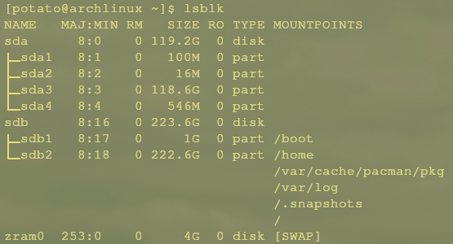
You should see two ssds with a bunch of partitions, for example:

sdb is my linux, it might be different for you. But it is easy to see which one is windows. Its the one with a partition with 100M mine is sda1. That is the bootloader. It’s like grub. But for windows and silent.
To confirm that sda1 is infact part of windws and the bootloader run the command:
“sudo blkid /dev/sda1” but you should have the name of your drive instead.
If it returns looking something like this:
You’re all good!
Then mount that drive to another folder like this:
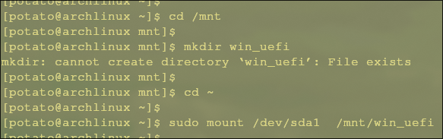
- First create the folder to mount to
- Then mount it:

Now download os-prober so grub can see windows.
“sudo pacman -S os-prober”
(tip: type clear or press CTRL+L to clear the terminal)
Now we need to make sure grub wants to use os-prober. To do that:
First make sure grub knows os-prober exists by typing:
“grub-mkconfig -o /boot/grub/grub.cfg”
and then make sure grub wants to use os-prober:
“sudo nano /etc/default/grub”
and go to the bottom (if it isn’t at the bottom look through the file) and locate
#GRUB_DISSABLE_OS_PROBER=false
and remvove the hashtag. Now grub likes os-prober!
Press CTRL+O then enter and then CTRL+X to save and quit.
Then run: “sudo grub-mkconfig -o /boot/grub/grub.cfg again
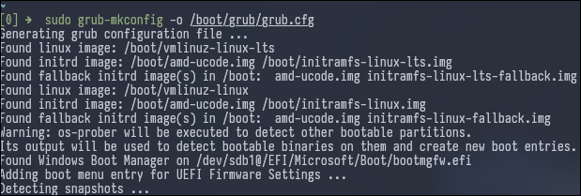
And now that’s all done!
Then reboot and select windows to set up everything there!
And activate windows https://github.com/NiREvil/windows-activation

Written with by QueDoom (discord: quedoom – Birdbob)
.. with help from @quollveth and the grub wiki.

